select employee_id,

CONCAT(first_name,last_name) NAME,

job_id,

LENGTH(last_name),

INSTR(last_name,'a') "Contains 'a'"

from hr.employees

where SUBSTR(job_id,4)='REP';

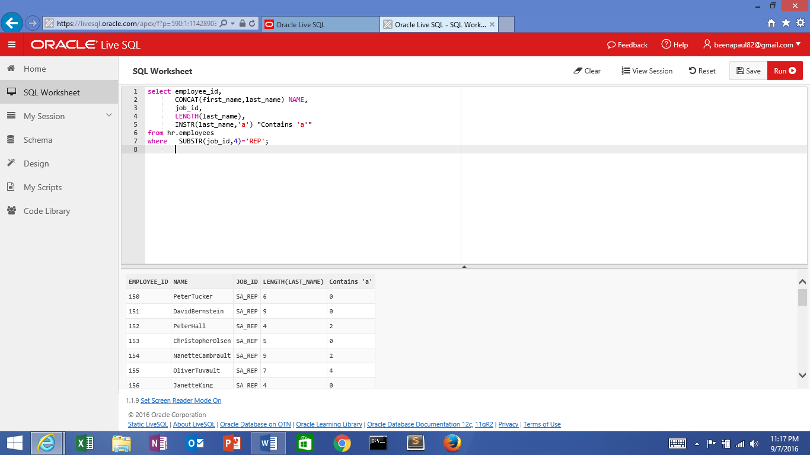

select employee_id,

CONCAT(first_name,last_name) NAME,

job_id,

LENGTH(last_name),

INSTR(last_name,'a') "Contains 'a'"

from hr.employees

where SUBSTR(job_id,-4,3)='_RE';

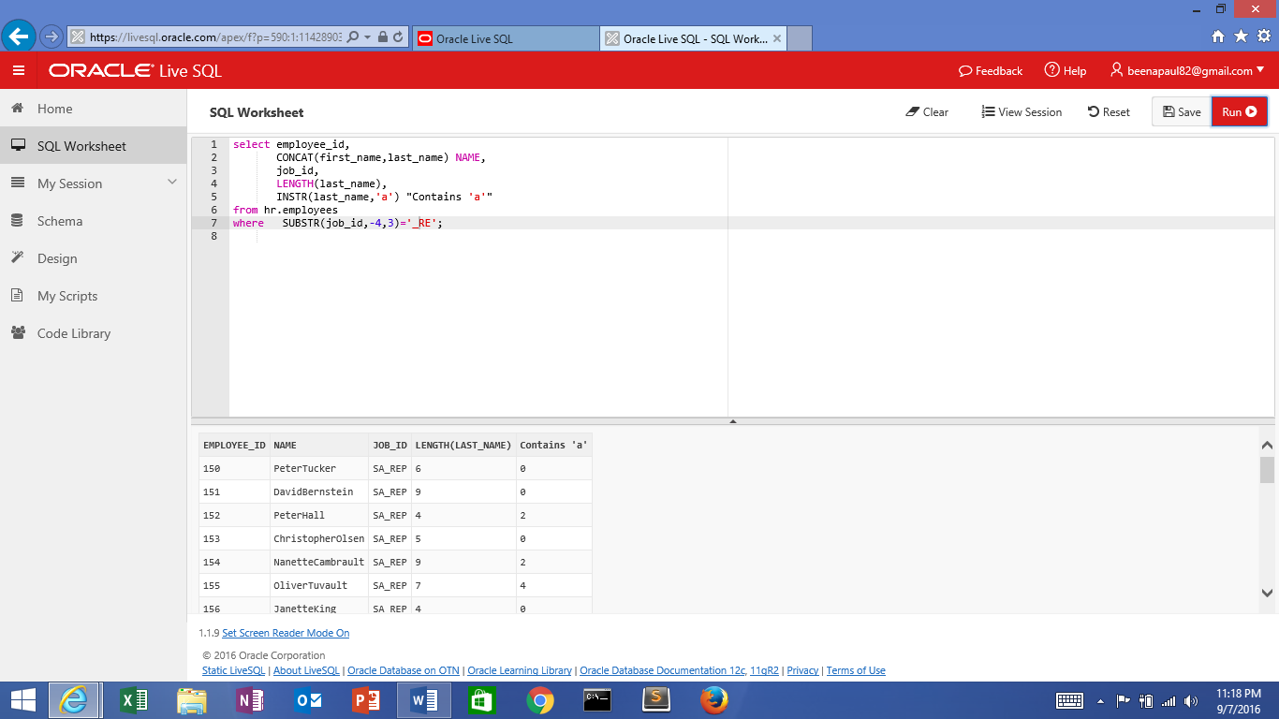

select salary, lpad(salary,6,'&') from hr.employees where job_id = 'SA_REP';

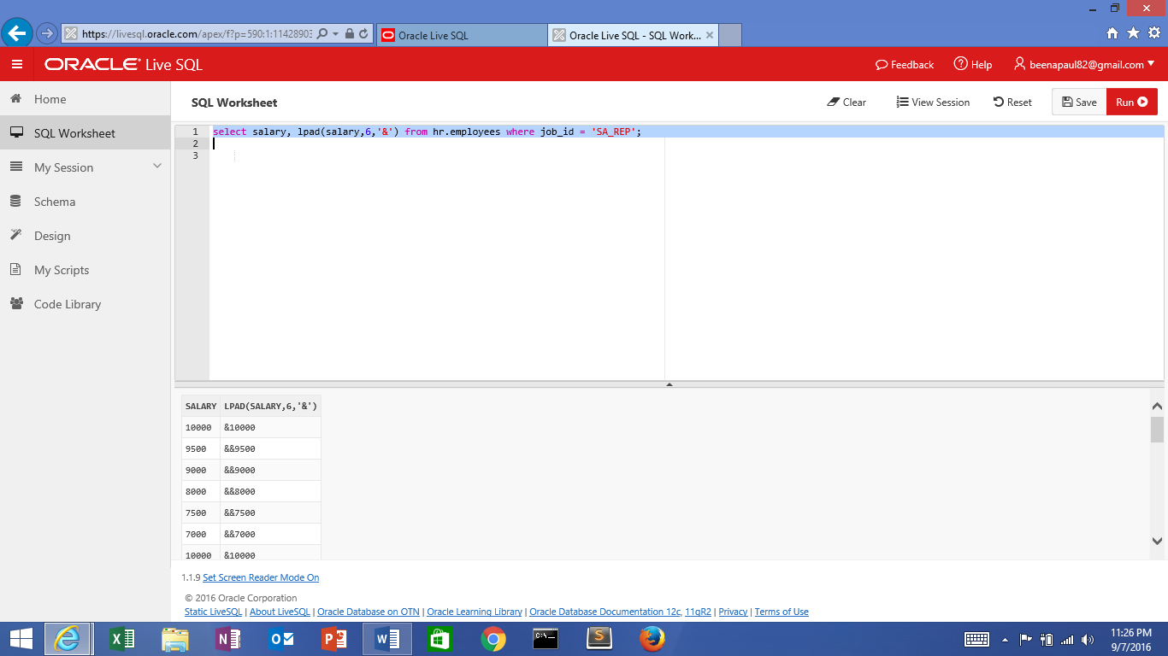

select job_id, rpad(job_id,8,'@') from hr.employees ;

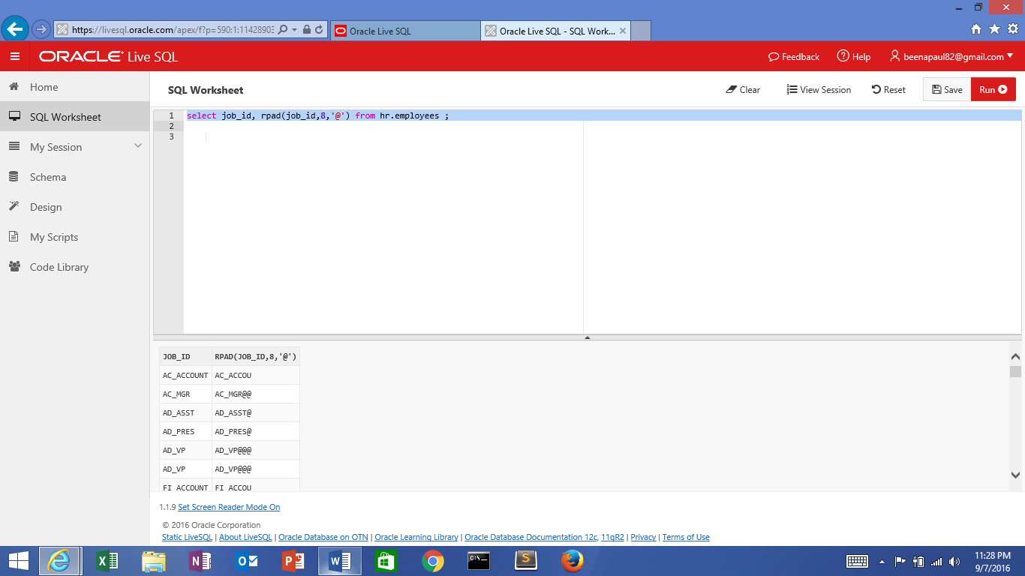

select first_name, REPLACE (first_name,'d','ZZ') from hr.employees ;

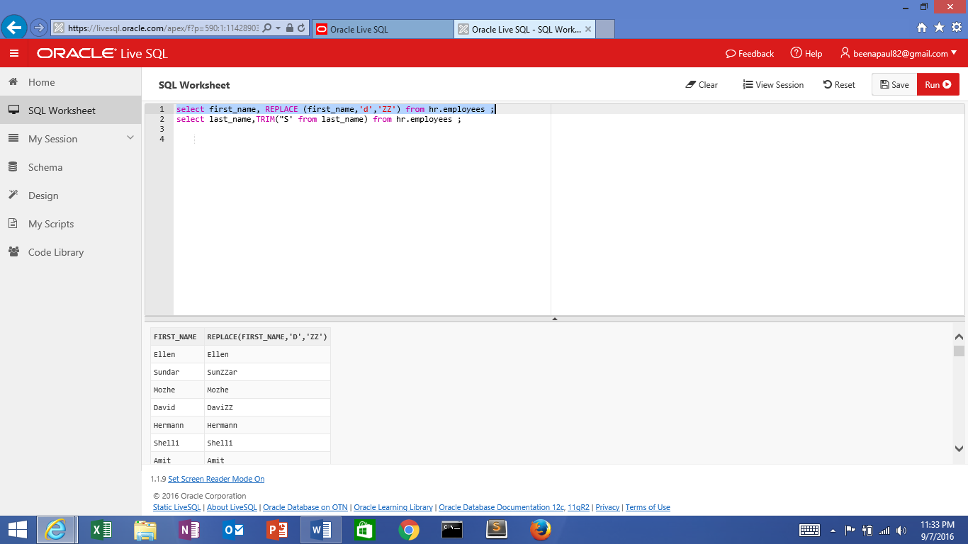

select last_name, TRIM('B' from last_name) from hr.employees ;

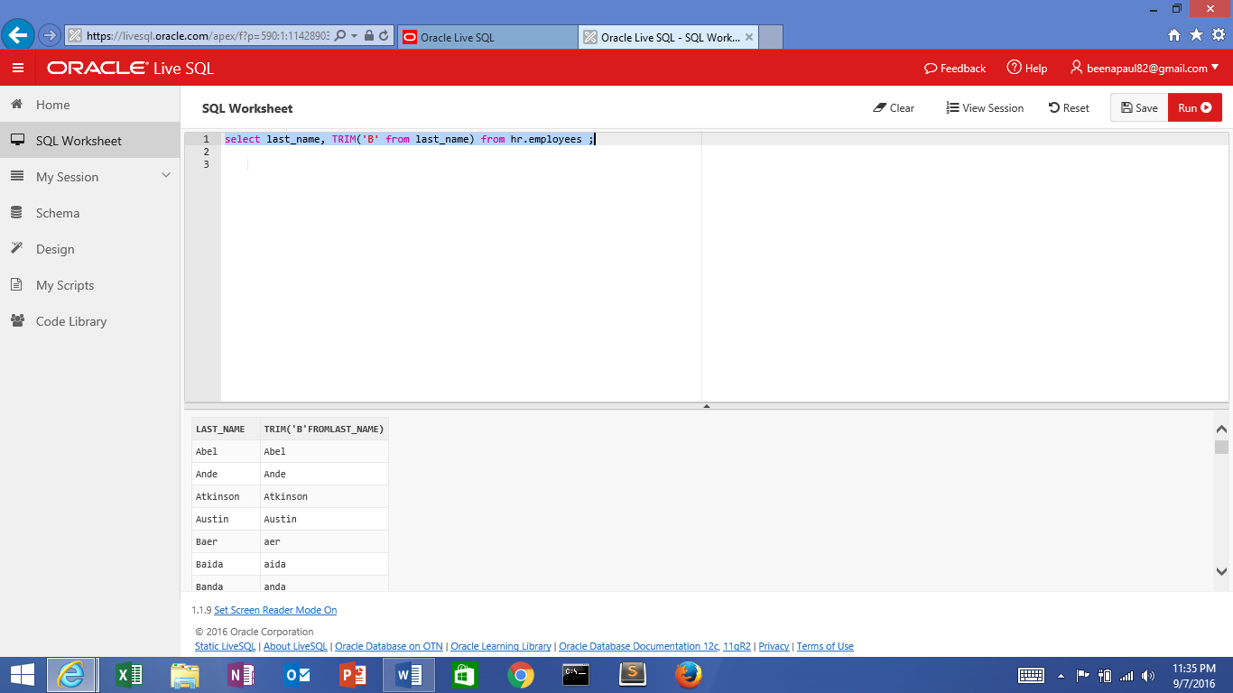

select AVG(salary), ROUND(AVG(salary),2), TRUNC(AVG(salary),2) from hr.employees;

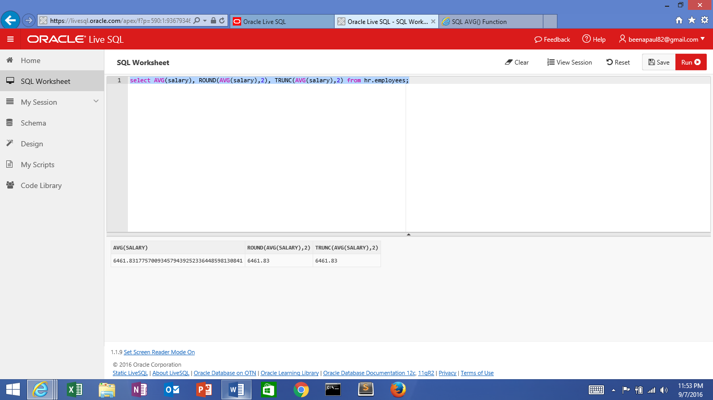

select (sysdate-hire_date)/7 as week from hr.employees;

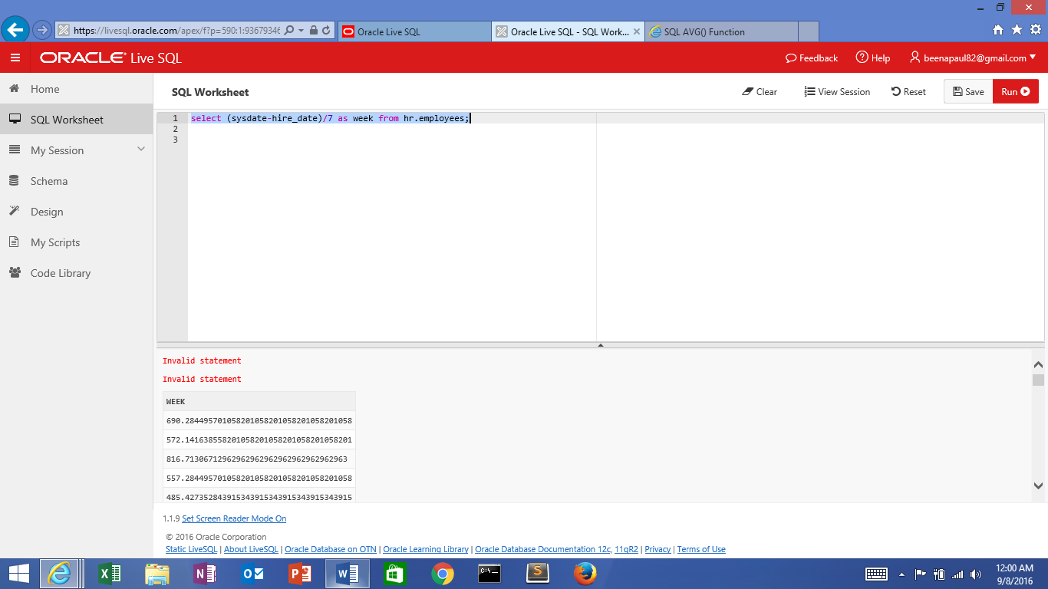

select round(sysdate,'year'),round(sysdate,'month'),trunc(sysdate,'year'),trunc(sysdate,'month') from dual;

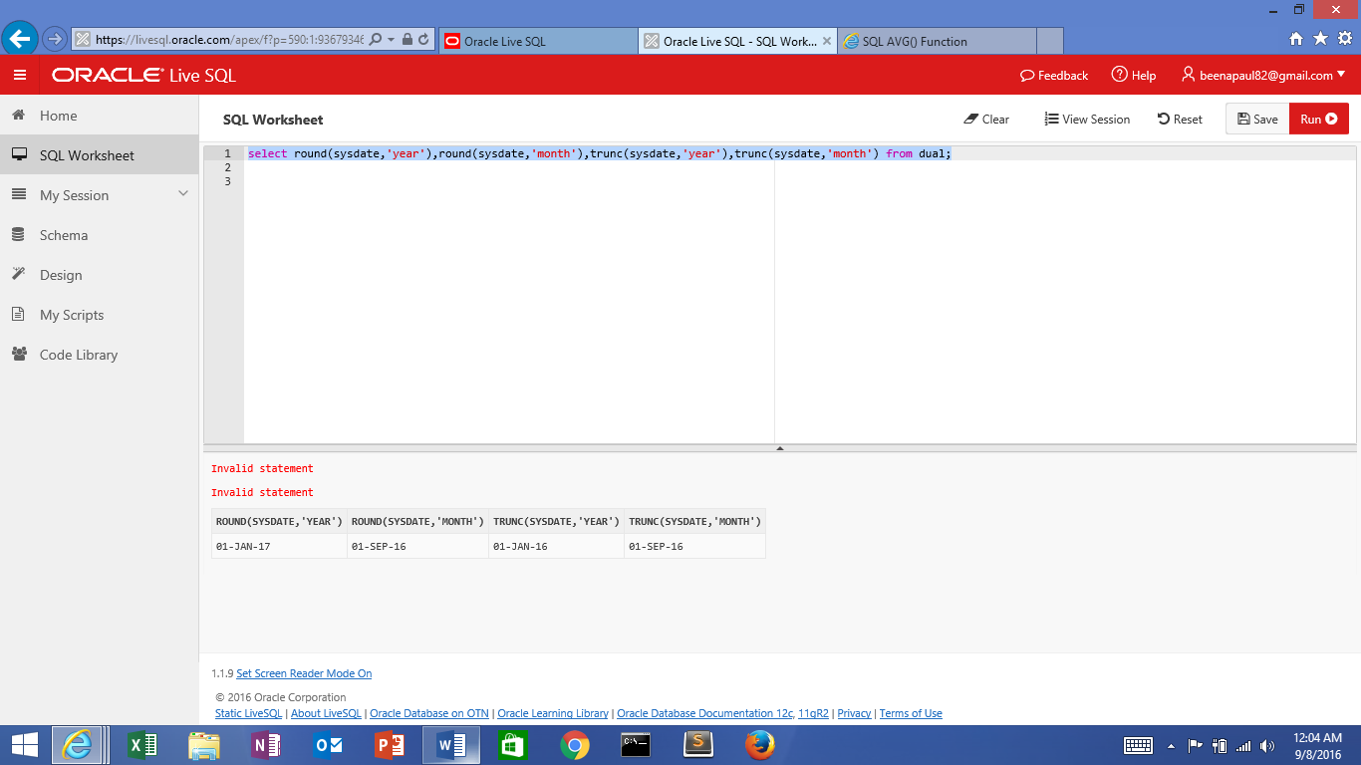

select next_day('08-SEP-16','monday') from dual;

select last_day('08-SEP-16') from dual;

select last_name,to_char(hire_date,'DD-MON-YYYY')

from hr.employees

where hire_date < TO_DATE('01-Jan-90','DD-Mon-YY');

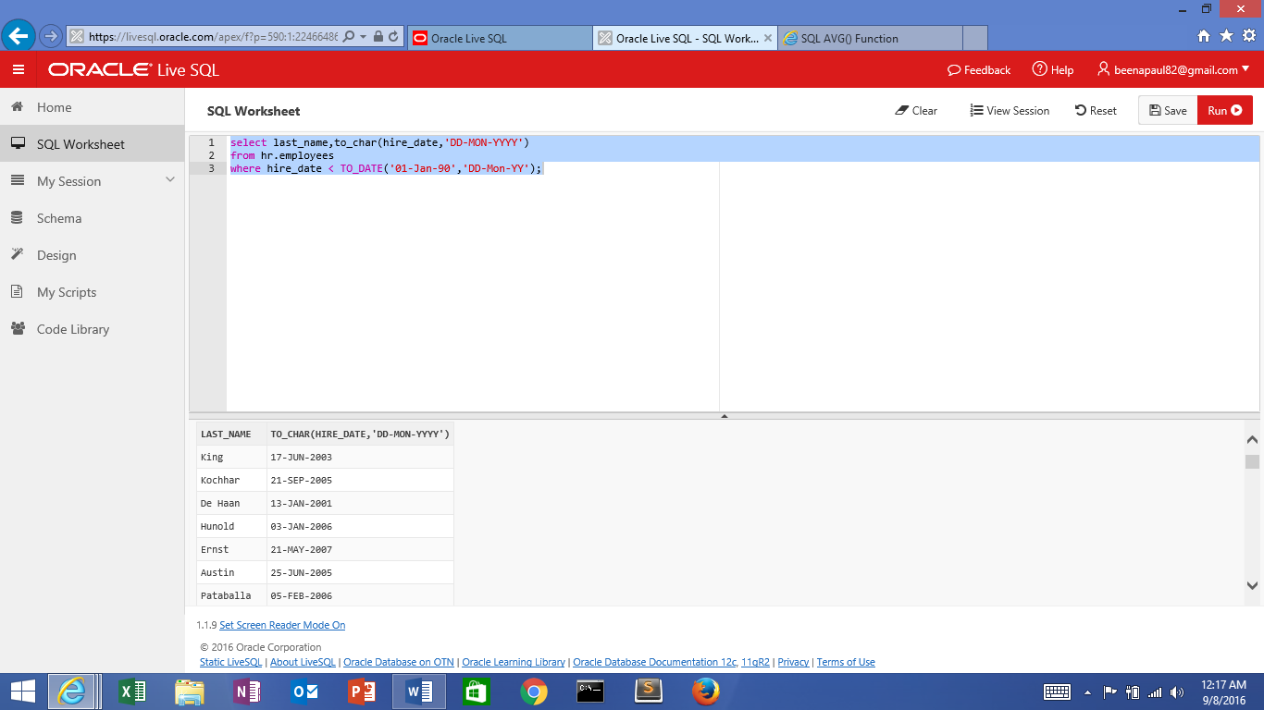

select last_name,to_char(hire_date,'DD-MONth-YYYY')

from hr.employees

where hire_date < TO_DATE('01-Jan-90','DD-Mon-YY');

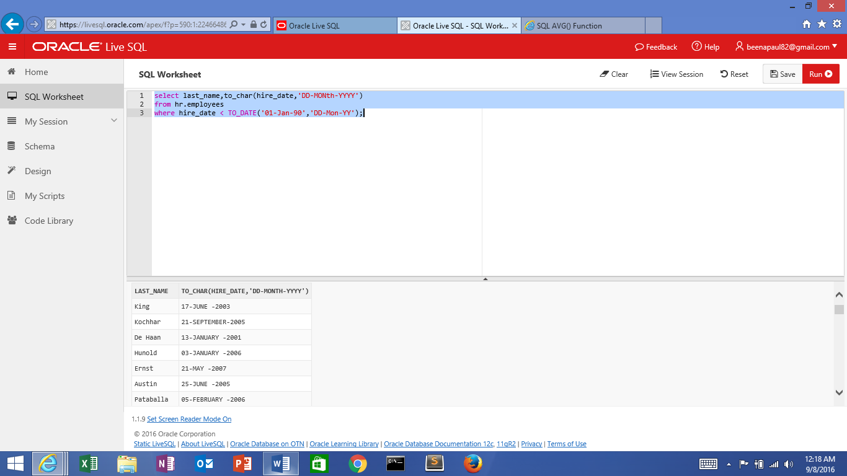

select last_name,to_char(hire_date,'DDspth-MONth-YYYY')

from hr.employees

where hire_date < TO_DATE('01-Jan-90','DD-Mon-YY');

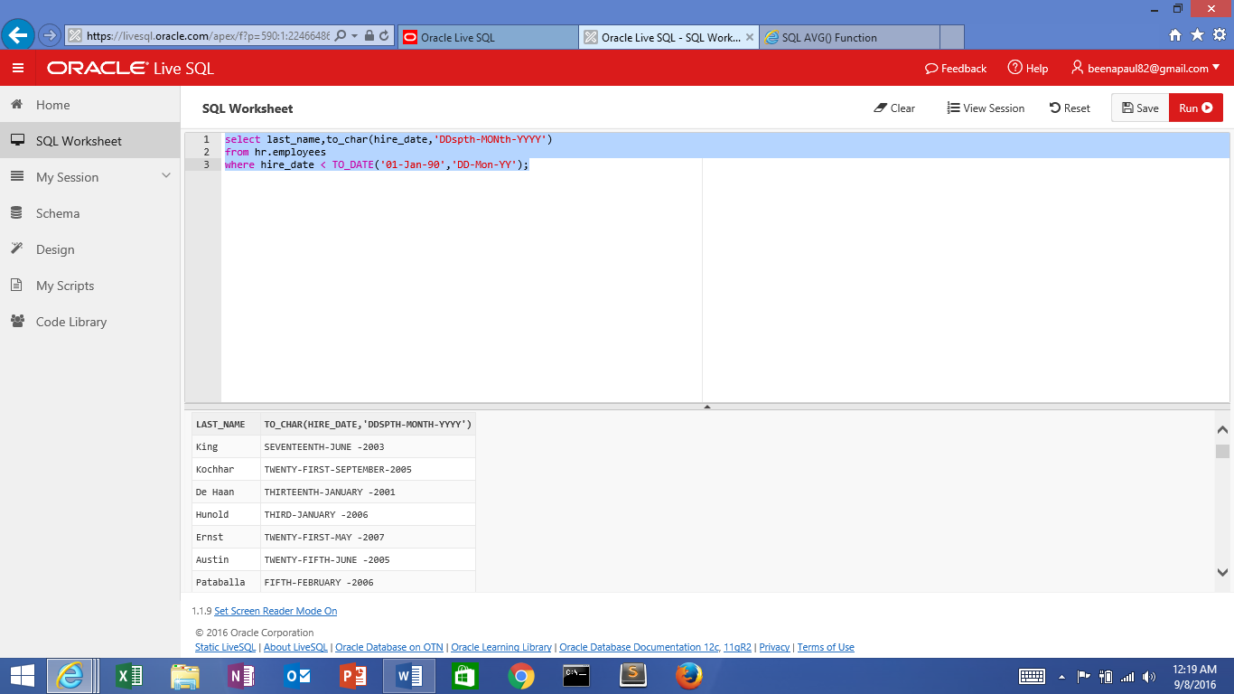

select last_name,to_char(hire_date,'DDspth-MONth-Year')

from hr.employees

where hire_date < TO_DATE('01-Jan-90','DD-Mon-YY');

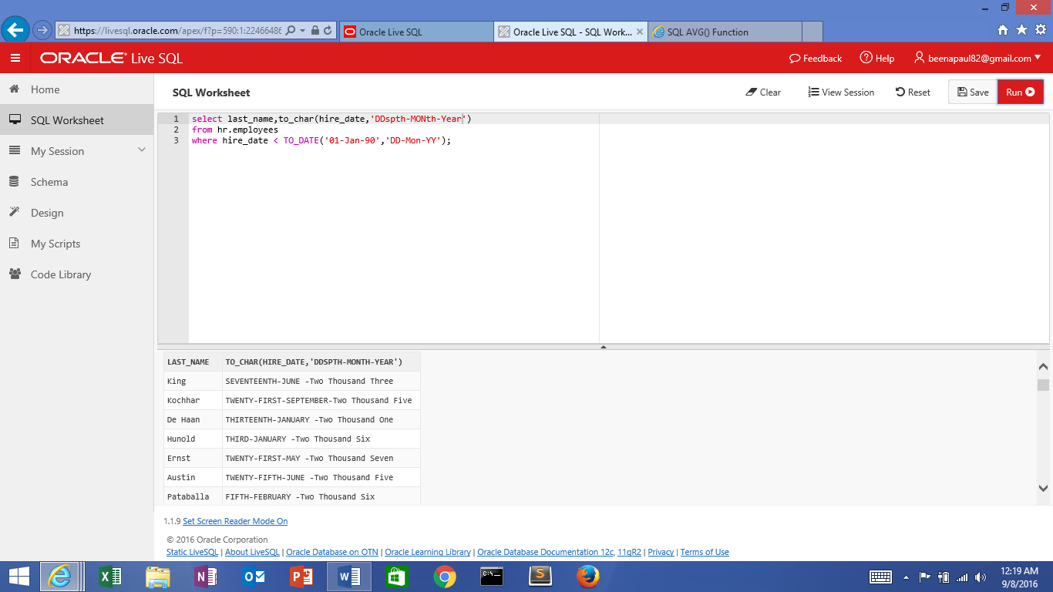

select last_name,to_char(hire_date,'DD-MON-yyyy')

from hr.employees

where hire_date < TO_DATE('01-Jan-99','DD-Mon-RR');

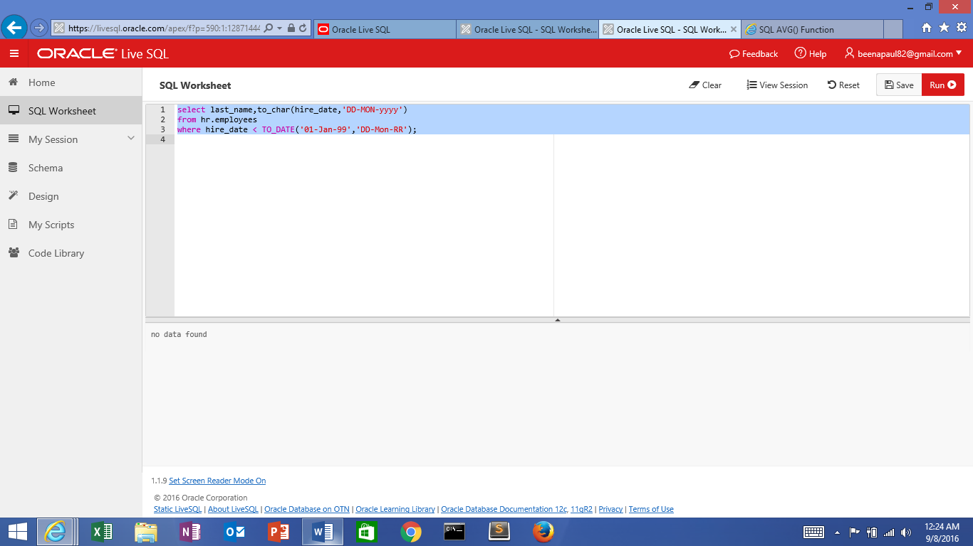

select last_name,to_char(hire_date,'DD-MON-yyyy')

from hr.employees

where hire_date < TO_DATE('01-Jan-99','DD-Mon-YY');

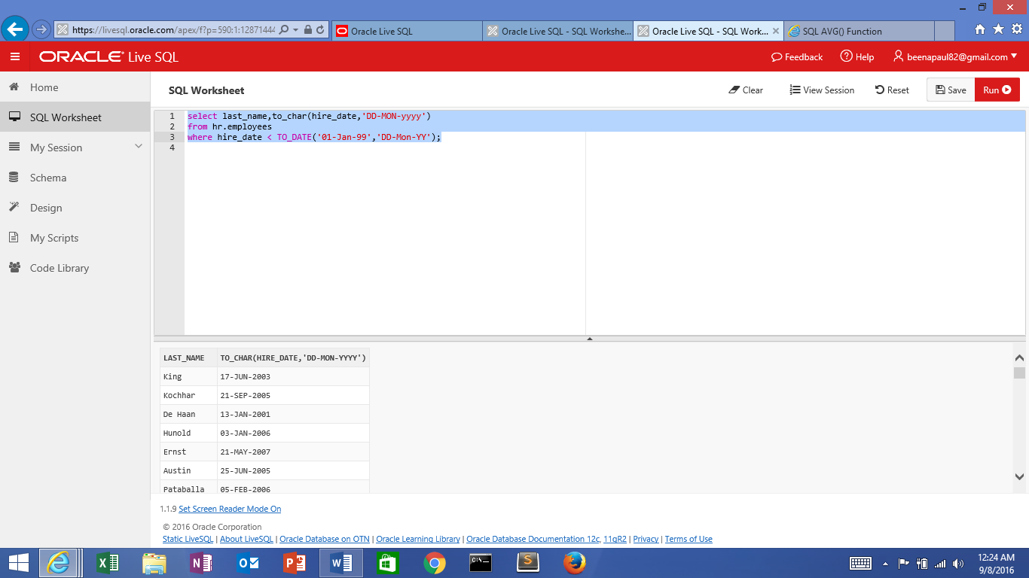

select last_name,upper(concat(substr(last_name,1,8),'_us'))

from hr.employees

where hire_date < TO_DATE('01-Jan-99','DD-Mon-YY');

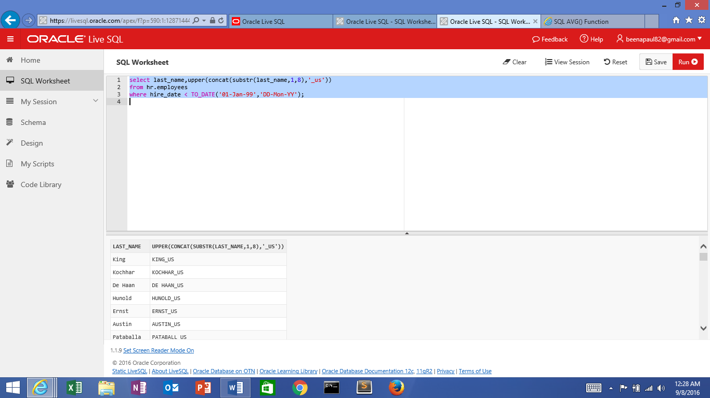

select commission_pct,salary+nvl(commission_pct,0)

from hr.employees

where hire_date < TO_DATE('01-Jan-99','DD-Mon-YY');

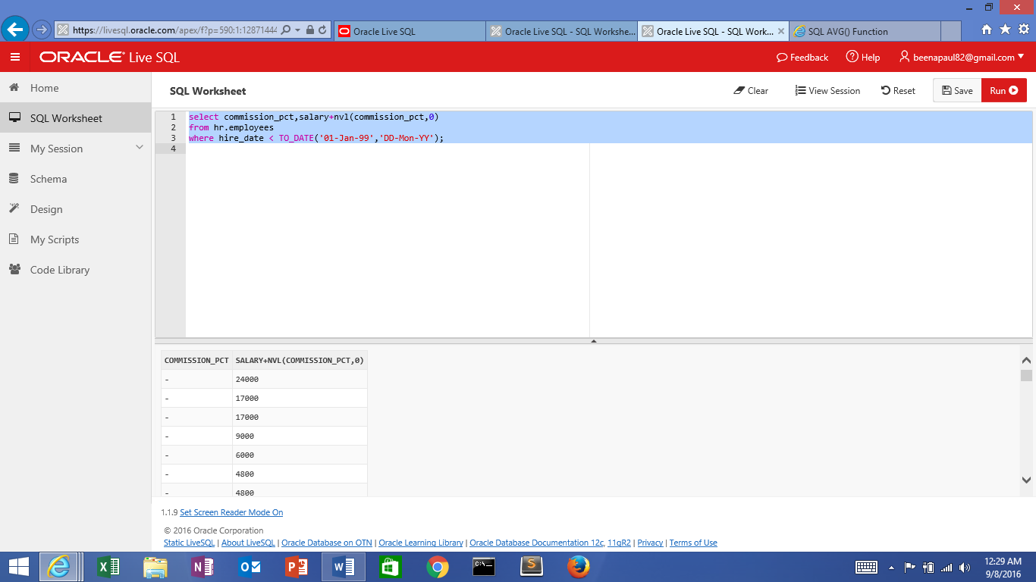

select commission_pct,NVL2(commission_pct,salary+commission_pct,salary)

from hr.employees

where hire_date < TO_DATE('01-Jan-99','DD-Mon-YY');

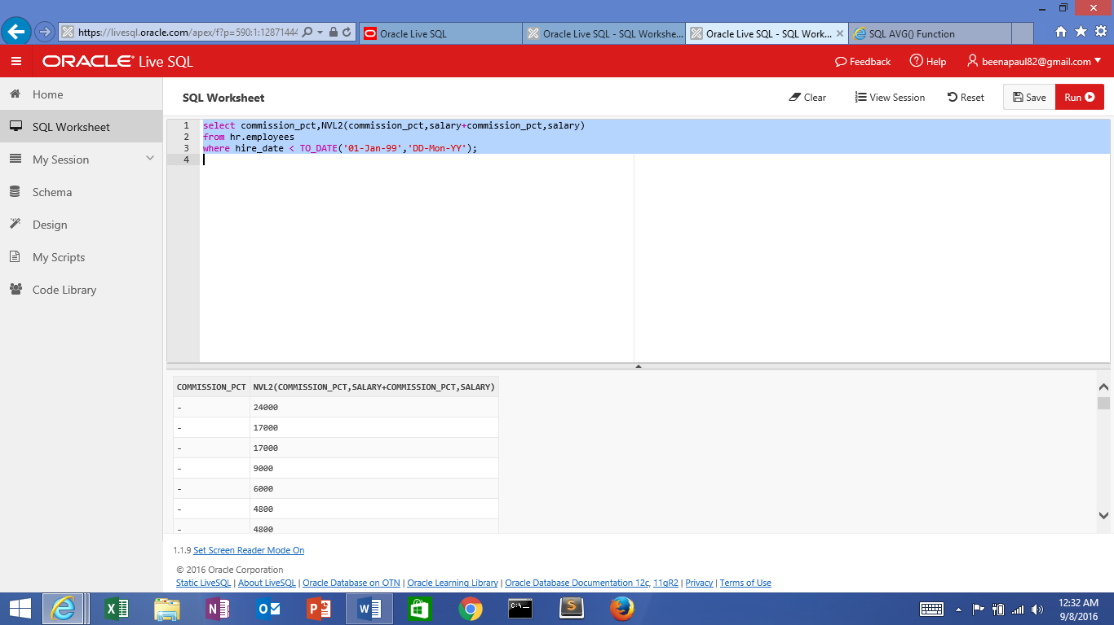

select first_name,last_name,NULLIF(length(first_name),length(last_name))

from hr.employees

where hire_date < TO_DATE('01-Jan-99','DD-Mon-YY');

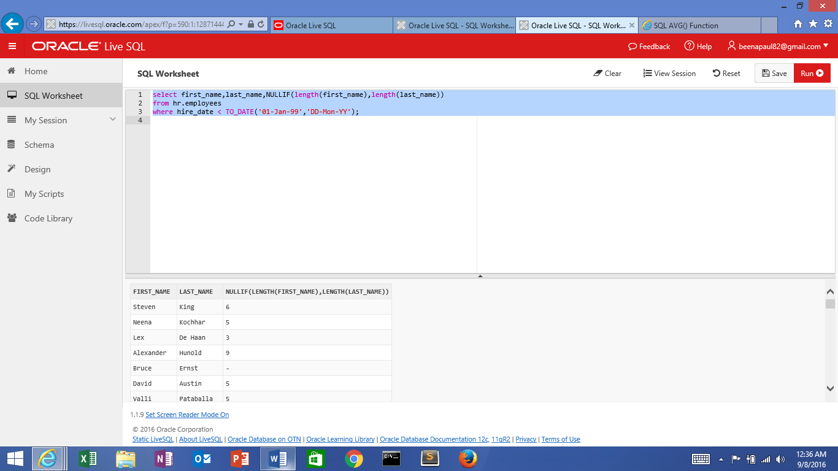

select manager_id,commission_pct,coalesce(manager_id,commission_pct,1111)

from hr.employees

where hire_date < TO_DATE('01-Jan-99','DD-Mon-YY');

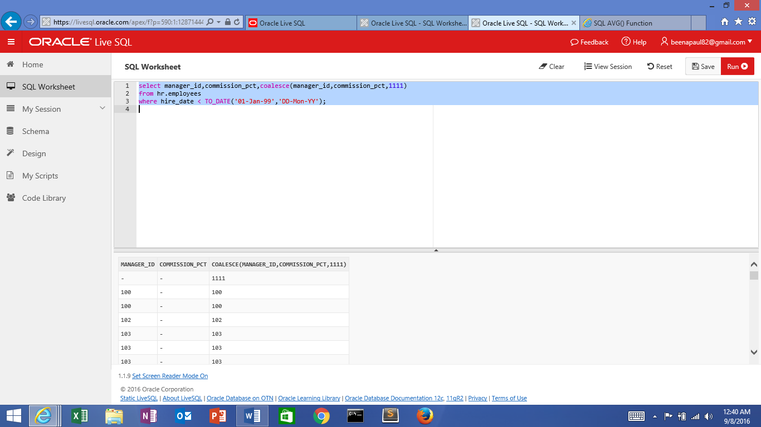

select job_id,salary,

CASE job_id WHEN 'IT_PROG' THEN 1.10*salary

WHEN 'AD_VP' THEN 1.20*salary

ELSE salary+1000

END "REVISED SALARY"

from hr.employees

where hire_date < TO_DATE('01-Jan-99','DD-Mon-YY');

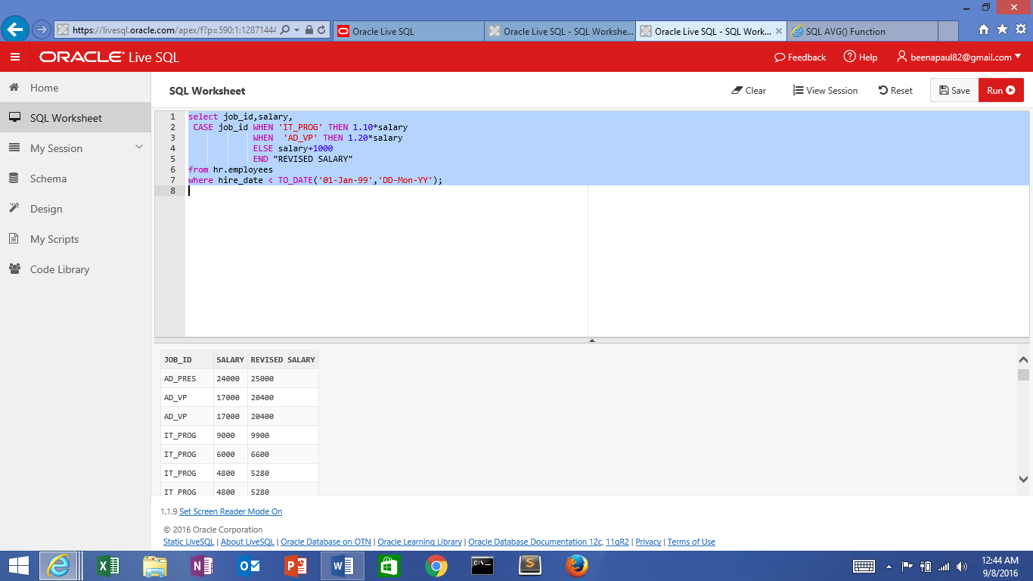

select job_id,salary,

DECODE (job_id , 'IT_PROG' , 1.10*salary,

'AD_VP', 1.20*salary,

salary+2000)

"REVISED SALARY"

from hr.employees

where hire_date < TO_DATE('01-Jan-99','DD-Mon-YY');

